PROJECT DESCRIPTION

Project # 1389-00-00 Date: 12/19/2014
Project Name: ESF Phantom
Customer: Dr. Reinhard Schulte
Division of Radiation Research
Department of Badic Sciences
Loma Linda University
11085 Campus Street
Loma Linda, CA 92350

Finished Device
Cylindrical phantom with embedded rectangular targets of varies composition and alignment holes at 0, 90 and 180 degrees. On the top right side, engraving targets edification for orientation proposes
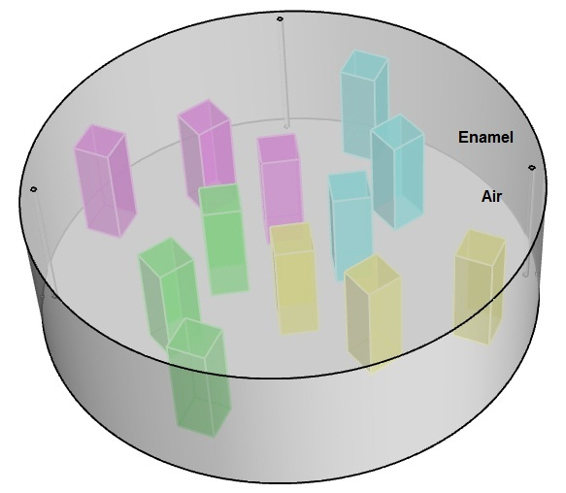

Illustration 1 Page 1 of 3

Dimensional:
Diameter = 200mm
- Height = 60mm
- Insert size = 15mm x 15mm x 45mm
- The targets are entirely embedded.
- The first target is located at theta =5 degrees.
- Each insert is separated from the next by 30 degrees, i.e. (5deg, 35deg, 65deg, 95 deg….)
- Each insert is rotated such that its edge is orthogonal to a radius.
- The three radii at which the inserts are positioned are 25 mm, 55 mm and 80 mm.
- Three alignment holes 2 mm in diameter located 95 mm from the center at angles theta 0, 90, 180 degrees. (Illustration 2)
- There is 7.5 mm of material overlaying both the top and the bottom surfaces of the targets.(Illustration 3)

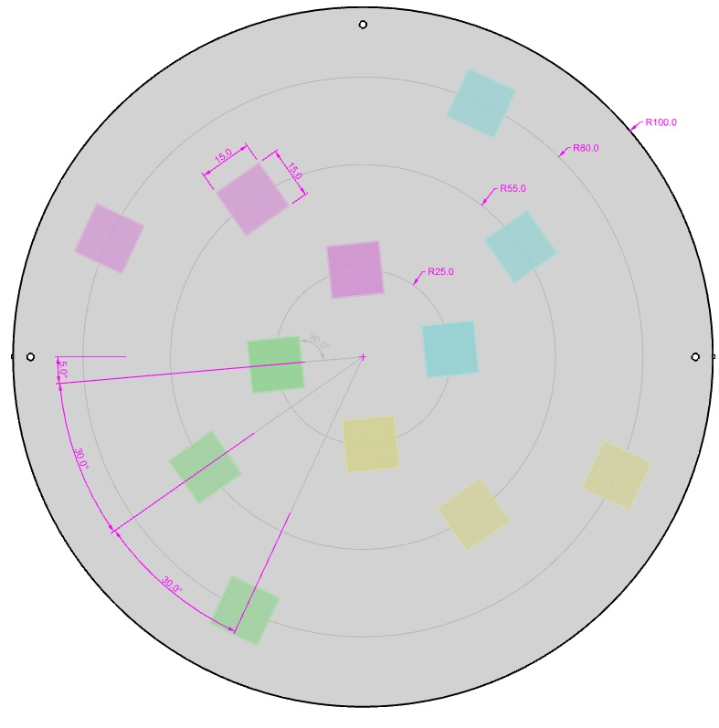
Illustration2 Page 2 of 3
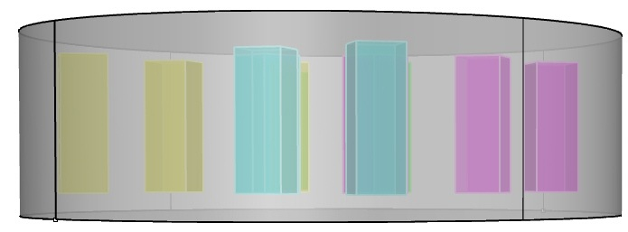
Illustration3

Material:
Phantom body composition: PWLR (Plastic Water Low Range)
Targets composition:
      - Teeth Enamel (represent in cyan color, see illustration 2)
      - Cortical Bone (represent in magenta color, see illustration 2)
      - Lung (represent in green color, see illustration 2)
      - Air (represent in yellow color, see illustration 2)

LABELING

Identifier Project # - Job ID
Exterior Labeling: CIRS Logo

PACKAGING

Considerations Standard packaging

WARRANTY 90 day limited warranty
Phantom to be manufactured as stated within this description.

Project Developer: Michael Komarovsky

Page 3 of 3

